Expt no:3 Configure DNS and DHCP protocols using Packet Tracer
3.1 DHCP Protocol
Objectives:
(i) To configure and verify the DHCP protocol for automatic IP address allocation to client devices in a network.
Software/Apparatus required:
(i) Cisco Packet Tracer
(ii) End Devices (PCs)
(iii) Switches
(iv) Copper Straight-through Cable / Automatic Cable Selector
(v) Routers
(vi) Server (DNS, HTTP and DHCP)
Procedure:
Objective 1: DHCP protocol
1. Create the required network topology using switches, a server, and PCs.
2. Connect all devices using appropriate network cables.
3. Open the server and enable the DHCP service.
4. Create a DHCP pool and specify the network parameters.
5. Configure the server with a static network address.
6. Open each PC and select DHCP in the IP Configuration settings.
7. Verify that the PCs automatically receive network configuration from the DHCP server.
8. Test communication between the PCs and the server using the ping command.
9. Save the Packet Tracer project.
Diagram
Objective 1: DHCP protocol
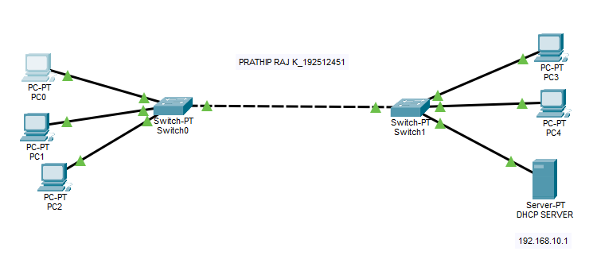
Output:
Objective 1: DHCP protocol
Sl. No | Source IP | Destination IP | Data sent (bytes) | Data received (bytes)
1 | 192.168.10.2 | 192.168.10.6 | 4 | 4
2 | 192.168.10.3 | 192.168.10.6 | 4 | 4
3 | 192.168.10.4 | 192.168.10.5 | 4 | 4
4 | 192.168.10.5 | 192.168.10.2 | 4 | 4
5 | 192.168.10.6 | 192.168.10.3 | 4 | 4

Results
Objective 1: DHCP Protocol
(i) The DHCP protocol was successfully configured, and the client devices automatically obtained network configuration parameters from the DHCP server.

